**ATAR HUMAN BIOLOGY**

**UNIT 1**

**Task 4 – Bone Practical**

**NAME: _____________________________________ WEIGHTING: 5%**

**DUE DATE: __________________________________ MARK: ______ /30 =**

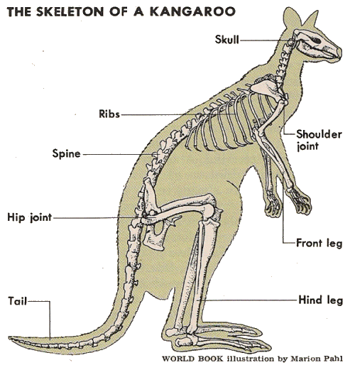A bone represents an organ of the skeletal system.  As such, it is composed of a variety of tissues, including; bone tissue, cartilage, dense connective tissue, blood, and nervous tissue. Bone tissue differs greatly from other tissues in the body. Bone is hard and many of its functions depend on that characteristic hardness. Bone density is a measure of the amount of mineral in bone tissue; it can be considered ‘bone hardness’, and there is a statistical correlation between low bone density and the risk of a fracture.

By examining how different bones fracture and the amount of force necessary to break them, we can understand more about how bone is structured. The skeleton of a Kangaroo is very similar to that of a human skeleton, and as such, we can use a Kangaroo skeleton to model the strength and structure of human bones.

Aim

To determine the relationship between the force required to fracture a bone and the density of different bones in the human body.

Materials

* Selection of bones from a kangaroo
* 2 desks
* Dustpan and broom
* 2 clamps
* 1 large hook
* Rope
* Weights
* Scale
* Blast screen
* Tarp
* Gloves
* Safety glasses
* Lab coat

Introduction.

1. Write a hypothesis for this experiment (2 marks)

________________________________________________________________________________________ ________________________________________________________________________________________

1. Identify the independent and dependent variable for this experiment (2 marks)

________________________________________________________________________________________ ________________________________________________________________________________________

1. Identify two variables in this experiment that need to be controlled and explain why they must be controlled.

(3 marks)

________________________________________________________________________________________ ________________________________________________________________________________________ ________________________________________________________________________________________ ________________________________________________________________________________________

*SAFETY NOTE: during this activity, you will be dealing with dead tissue and there is a high chance that small bone fragments will fly through the air. As such, all group members must wear lab coats, safety glasses and gloves.*

Method.

1. Each group member must put on a lab coat, safety glasses and gloves.
2. In Table 2, record several observations about each of the bones laid out on the bench.
3. In a group of 3, select one bone to investigate.
4. Determine the density of your group’s bone by:
   1. Finding the mass of the bone using a scale and recording the mass in Table 1.
   2. Finding the volume of the bone using a water displacement method. Fill a container with a known amount of water (this will vary depending on your selected bone), place the bone in the container so that it is completely submerged and then record the change in volume of the water in Table 1.
   3. Determine the bone density by dividing the mass by the volume. Record this in Table 1 also.
5. Predict how many Newtons of force (mass x gravity 10m/s2) the bone can withstand and record in Table 1.
6. As directed by your teacher, you must determine the force (force is calculated by mass x gravity 10m/s2) needed to fracture (break) your chosen bone. Using the Bone Crushing set-up, you will be clamping your bone between two tables and hanging weight from its centre. Slowly add more and more weight, being careful to keep your feet away from the floor directly underneath the bone. Continue to add weight until the bone snaps. In Table 1, record the **force** needed to break your bone.
7. In Table 2, record several observations about how your bone fractured. For example, did the bone break into multiple pieces; break at the end or the middle; break straight across, at an angle or in a spiral; or not break all the way across?
8. The rest of the table has been filled in using data from previous experiments using kangaroo bones.
9. Using a hammer apply a small force to a selection of other bones and observe their structure.

**Table 1. The relationship between bone density and the break point in a range of Kangaroo bones.** (2 marks)

|  |  |  |  |  |  |
| --- | --- | --- | --- | --- | --- |
| **Bone** | **Mass (g)** | **Volume (cm3)** | **Density (g/cm3)** | **Predicted force for fracture (N)** | **Actual force for fracture (N)** |
| Ribs |  |  |  |  |  |
| Spine/vertebrae |  |  | 1.6 |  | 100N |
| Femur |  |  | 1.85 |  | 4000N |
| Pelvis |  |  | 1.92 |  | 5500N |
| Skull |  |  | 2.8 |  | 8000N |

**Table 2. Observations of different bones after fracturing or breaking with a hammer.**

|  |  |  |
| --- | --- | --- |
| **Bone** | **Observation** | |
| **Prior to hitting** | **After fracture** |
| Rib |  |  |
| Spine/vertebrae |  |  |
| Femur |  |  |
| Fresh chicken bone |  |  |

Results.

1. Using the grid below, create a graph to represent the relationship between bone density and the force needed to cause a fracture. (5 marks)

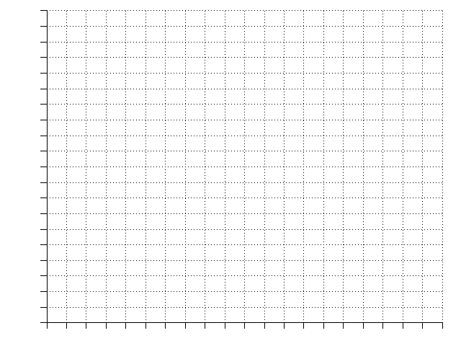

1. Describe the relationship found in your experiment between bone density and the force required to break a bone. (2 marks)

________________________________________________________________________________________ ________________________________________________________________________________________ ________________________________________________________________________________________ ________________________________________________________________________________________

1. Write a scientific conclusion to this experiment. (2 marks)

________________________________________________________________________________________ ________________________________________________________________________________________ ________________________________________________________________________________________ ________________________________________________________________________________________ ________________________________________________________________________________________

1. Explain whether this was a valid experiment. (2 marks)

________________________________________________________________________________________ ________________________________________________________________________________________ ________________________________________________________________________________________ ________________________________________________________________________________________

Discussion.

1. This experiment was conducted using dead bone tissue. Explain why this would have affected the amount of force required to fracture the bones compared to living tissue. (3 marks)

________________________________________________________________________________________ ________________________________________________________________________________________ ________________________________________________________________________________________ ________________________________________________________________________________________ ________________________________________________________________________________________ ________________________________________________________________________________________

1. By referring to the structure of a long-bone, explain whether you believe that the direction of force would change how much force would be required to break your bone. (4 marks)

________________________________________________________________________________________ ________________________________________________________________________________________ ________________________________________________________________________________________ ________________________________________________________________________________________ ________________________________________________________________________________________ ________________________________________________________________________________________ ________________________________________________________________________________________ ________________________________________________________________________________________

1. Evaluate the following statement:

“*It is important that the femur is stronger than the radius in a human*” (3 marks)

________________________________________________________________________________________ ________________________________________________________________________________________ ________________________________________________________________________________________ ________________________________________________________________________________________________________________________________________________________________________________________________________________________________________________________________________________________________________________________________________________________________

**Teacher notes.**

1. Set-up bones on separate table, bone crusher area with tarp on group and blast shield, and have buckets and scales ready at back of classroom for students to determine bone density.
2. Start assessment by showing this video

* Show students some videos of bones fracturing; note that these are graphic and some images may be disturbing. Example 1:30-minute video, Louisville Kevin Ware Leg Break in March Madness, shows a basketball player breaking his leg: http://www.youtube.com/watch?v=YZW58xPz8kI

1. Lay out each bone on a different table so that students can complete observations of the bones
2. Organise students into groups of 3. Assign each group a bone.